Name: ________________________________ Date: ___________________________________

Class: _________________________________ Teacher: ___________________________________

# Effective Graphics

1) You have the data for the number of cases for the first 20 days COVID was detected in the United States.

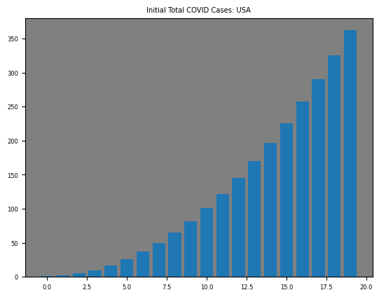

How could you make this graphic more effective at communicating a story?

2) You have the graph from Math MiniQuiz 2. You’re on the varsity softball team. You’re at an away game and someone on your school’s baseball team comes to you and says they forgot to fill their water cooler! You tell them not to worry because you’re happy to share some of your water. You tell them to open the top of their cooler, which already had some water in it, and you start pouring some water into their cooler. As you pour, below are the graphs of the water in each cooler over time.

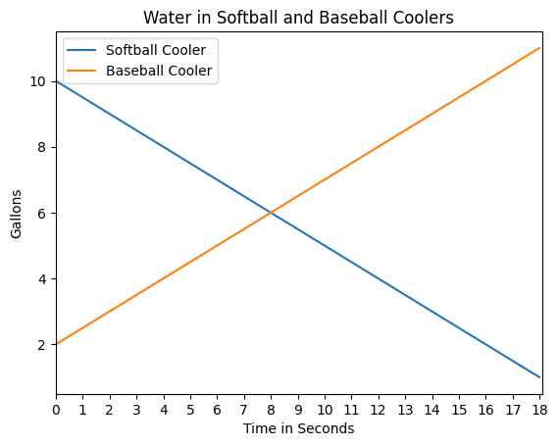

How could you make this graphic more effective at communicating a story?

3) Here you have the average temperature each day of the year in Baltimore

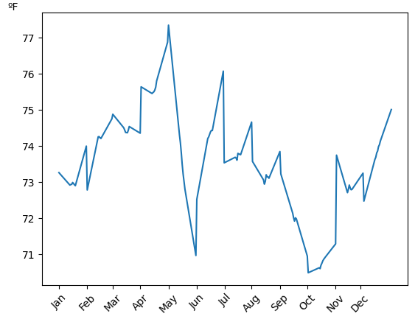

How could you make this graphic more effective at communicating a story?